```DIS-Asia-China-Sanxingdui

**Sanxingdui** (三星堆; Sānxīngduī, "three star mound") archaeological site is located about 4 km northeast of Nanxing Township, Guanghan County, Chengdu Prefecture, Sichuan Province, 40 km north of Chengdu.

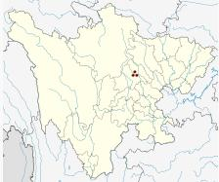 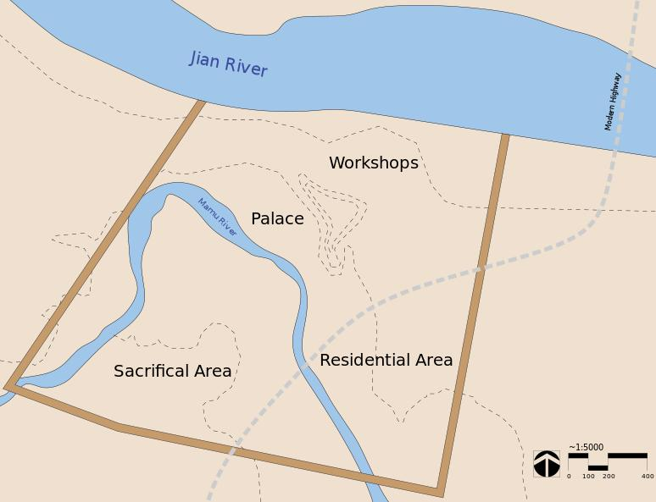

Sanxingdui site.(30° 59′ 34.8″ N, 104° 12′ 0″ E). Left, Location in Sichuan Province; right map of city wall enclosing ca. 2.6 sq. km. and 4 major cultural areas.

The first inking of the Sanxingdui culture was in 1929 when a farmer uncovered a hoard of jade relics which made teir way into the antiques market over the next five decades. However, not until 1980 was excavation begun on the site. It was discovered that its extensive walls were of a rammed earth, *hangtu* construction, which involved putting wet, lacustrine clay into wooden frames which was compacted to produce a uniformly hard layer 12-15 cm. thick. Several courses were laid to achieve the desired height (Knapp 2000; Rael 2009). An estimation as to the original height and geometry of the wall can then be made using a modeling technique that accounts for the degradation of the structure over time (Panin, Arzhantseva, Oleaga 2012). By this means the wall was estimated to enclose an area of 2.6 sq. km., indicating that it enclosed a major settlement.

In 1986 two sacrificial pits (K1 and K2) were discovered which were separated by a few decades, around 1200 BCE. In K1, the earlier pit, a unique ritual, an offering ceremony, was uncovered in which burned and broken artifacts of bronze, jade and gold, 13 elephant tusks, cowrie shells and burned animal bones were deposited into the pit. The jades included axes, tablets, rings, knives and tubular shapes with a central hole that were decorated with taotie-like images in relief. The second pit, K2, contained an even more rich content in three layers with more than a hundred jade artifacts, a bronze statue on a pedestal 262 cm tall, 41 bronze heads (some with gold leaf), bronze masks and three bronze trees (one 4 m tall). The art forms in these pits are of an entirely unknown Chinese culture which has been named Sanxingdui.

As far back as Neolithic times, the Chinese identified the four quadrants of the sky with animals: [Azure Dragon of the East](http://en.wikipedia.org/wiki/Azure_Dragon), [Vermillion Bird of the South](http://en.wikipedia.org/wiki/Vermilion_Bird), [White Tiger of the West](http://en.wikipedia.org/wiki/White_Tiger_(Chinese_constellation)), and [Black Tortoise of the North](http://en.wikipedia.org/wiki/Black_Tortoise). Each of these [Four Symbols (Chinese constellation)](http://en.wikipedia.org/wiki/Four_Symbols_(Chinese_constellation)) was associated with a constellation that was visible in the relevant season: the dragon in the spring, the bird in the summer, etc. Since these four animals — birds, dragons, snakes and tigers — predominate the finds at Sanxingdui,[[*citation needed*](http://en.wikipedia.org/wiki/Wikipedia:Citation_needed)] the bronzes could represent the universe.[[*citation needed*](http://en.wikipedia.org/wiki/Wikipedia:Citation_needed)] It is unclear whether they formed part of ritual events designed to communicate with the spirits of the universe (or ancestral spirits). As no written records remain it is difficult to determine the intended uses of objects found. Some believe that the continued presence of depictions of these animals, especially in the later Han period, was an attempt by humans to "fit into" their understanding of their world. (The jades that were found at Sanxingdui also seem to correlate with the six known types of ritual jades of ancient China, again each associated with a compass point (N, S, E, W) plus the heavens and earth.)

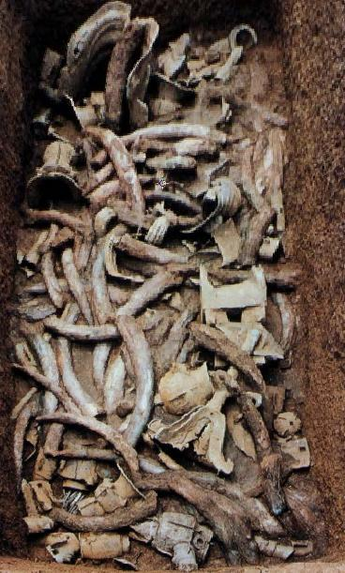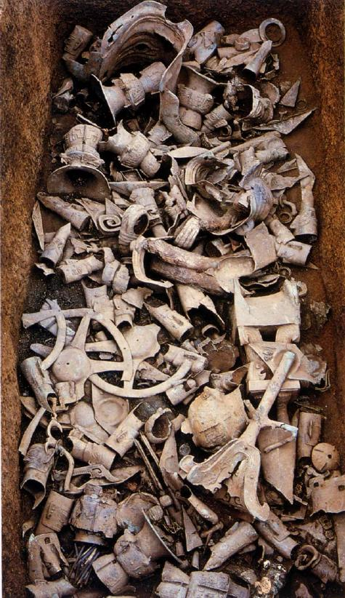

Fig. Left, Sanxingdui, K2 top layer after Taibei 1999: 194; right, K2 middle layer after Taibei 1999: 196.

Sanxingdui culture does not appear to have been in contact with the Bronze Age culture at Anyang. However after the abandonment of Sanxingdui in the 12th century BCE it appears that many relocated to a site about 50 km away.

This site named **Jinsha** ([金沙](http://en.wiktionary.org/wiki/金沙), *Jīnshā*) on the banks of the Modi River (摸底河) was discovered in February 2001 during building construction. Its excavation yielded artifacts of ivory, jade, bronze, gold and carved stone objects that suggests that it was the final phase of Sanxingdui culture that lasted until ca. 650 BCE as a political center in the Shu Kingdom. Unlike Sanxingdui there were no rammed earth fortification walls around the area of about five sq. km., roughly twice the size of its predecessor. Ivory, jade artifacts, bronze objects, gold objects and carved stone objects were found at the site. Unlike the site at Sanxingdui, Jinsha did not have a city wall. Jinsha culture (1200–650 BC) was a final phase of Sanxingdui culture and represents a relocation of the political center that some suggest was the ancient Shu Kingdom. (蜀; Shǔ) that was conquered by the state of [Qin](http://en.wikipedia.org/wiki/Qin_(state)) in 316 BCE (Yinke, Avery, Pan 2001: 171). Unfortunately, written accounts of Shu mostly date not earlier than the 4th century BCE and are largely a mixture of mythological stories and historical legends from local annals based on oral history. However there are possible references to "Shu" (蜀) in Shang oracle bone inscriptions, but it is not clear if they refer to the kingdom (Kleeman 1998: 19-22). The Shu was first mentioned in [*Shujing*](http://en.wikipedia.org/wiki/Shujing) (See Legge 1865, 1879) as one of the allies of [King Wu of Zhou](http://en.wikipedia.org/wiki/King_Wu_of_Zhou) who helped defeated the [Shang](http://en.wikipedia.org/wiki/Shang_Dynasty) in 1046 BC at the [Battle of Muye](http://en.wikipedia.org/wiki/Battle_of_Muye).[[2]](http://en.wikipedia.org/wiki/Shu_(state)" \l "cite_note-2) However, shortly after Zhou's conquest, it was mentioned in [*Yizhoushu*](http://en.wikipedia.org/wiki/Yizhoushu) that a subordinate of King Wu led an expedition against Shu.[[1]](http://en.wikipedia.org/wiki/Shu_(state)" \l "cite_note-ta_cheng-1) After the battle of Muye, northern influences on Shu seem to have increased and then decreased while the Shu remained culturally distinct; archaeology suggests contacts with Shu in the late Shang and early Zhou period, but little evidence of influence from later Zhou.[[1]](http://en.wikipedia.org/wiki/Shu_(state)" \l "cite_note-ta_cheng-1) The expulsion of the Zhou from the [Wei River](http://en.wikipedia.org/wiki/Wei_River) valley in 771 BC probably increased Shu's isolation.

The unique bronze heads with bulging eyes that are found in both Sanxingdui and Jinsha may be elucidated by a bit of oral history preserved in the *Chronicles of Huayang* (華陽國志; Huáyáng Guó Zhì), which is devoted to the region south of Hua mountain, (**Hua Shan**: 華山; [*Huà*](http://en.wiktionary.org/wiki/Huà) [*Shān*](http://en.wiktionary.org/wiki/Shān)), one of China's Five Great Mountains. Hua Shan, located about 120 km. (75 mi.) east of [Xi'an](http://en.wikipedia.org/wiki/Xi'an). **Hua Shan** has a long history of religious significance due in part to its majestic South Peak at 2,154.9 m. (7,070 ft.). In the *Chronicles,* compiledbetween 265 and 420 CE by Chang Qu during the Jin Dynasty, the first of the legendary kings named Cancong was reported to have had protruding eyes. Although the text is very late, its mention of the physical nature of this legendary king's eyes may have some bearing on the unusual appearance of the Sanxangdui culture's unique bronze heads. Protruding eyes may have been seen as an auspicious sign for a spiritual seer, a ruler who had visionary powers for the Sanxingdui culture.

[Legge, James](http://en.wikipedia.org/wiki/James_Legge) (1865). *The Chinese Classics, volume III: the Shoo King or the Book of Historical Documents*. London: Trubner. (Full Chinese text with English translation using Legge's own romanization system,

Legge, James (1879). [*The Shû king; The religious portions of the Shih king; The Hsiâo king*](http://www.archive.org/details/sacredbooksofch03conf). [Sacred Books of the East](http://en.wikipedia.org/wiki/Sacred_Books_of_the_East) **3**. Oxford: Clarendon Press

Terry F. Kleeman (1998). *[Ta Ch'eng, Great Perfection - Religion and Ethnicity in a Chinese Millenial Kingdom](http://books.google.co.uk/books?id=FAJrw0yInnAC&pg=PA19&lpg=PA19&f=false" \l "v=onepage&q&f=false)*. University of Hawaii Press. pp. 19–22.

Yinke, Deng; Martha Avery, Yue Pan (2008). [*History of China*](http://books.google.com/books?id=lFRVNTo77vEC&dq=jinsha+state+of+shu&source=gbs_navlinks_s). 五洲传播出版社. Beijing: China Intercontinental Press.

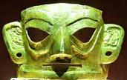

Fig. Junsha bronze mask silimar to those at Saningdui. From Jinsha Museum,

The **Shu** Kingdom (蜀; Shǔ) or [state](http://en.wikipedia.org/wiki/State_(Ancient_China)) in what is now [Sichuan](http://en.wikipedia.org/wiki/Sichuan), [China](http://en.wikipedia.org/wiki/China). Shu was based on the [Chengdu Plain](http://en.wikipedia.org/wiki/Chengdu_Plain), in the western [Sichuan basin](http://en.wikipedia.org/wiki/Sichuan_basin) with some extension northeast to the upper [Han River valley](http://en.wikipedia.org/wiki/Han_River_(Hanshui)). To the east was [the Ba tribal confederation](http://en.wikipedia.org/wiki/Ba_(state)). Further east down the Han and Yangtze rivers was the [State of Chu](http://en.wikipedia.org/wiki/Chu_(state)). To the north over the [Qinling Mountains](http://en.wikipedia.org/wiki/Qinling_Mountains) was the [State of Qin](http://en.wikipedia.org/wiki/Qin_(state)). To the west and south were tribal peoples of little military power.

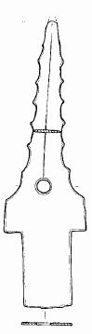 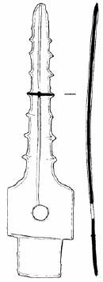

Fig. Left Sanxingdui serrated bronze *ge* blade, 20.5 cm., after Beijing 1999a: 56, fig. 32.5; right, Jinsha serrated bronze *ge* bladeafter Beijing2002c: 56.

*ge*-blades on the other hand, appear to have some resemblance to those of Fu Hao's tomb.

Knapp, R. G. 2000. China's old dwellings. Honolulu: University of Hawai'i Press.

Panin, V.; Arzhantseva, A.; Oleaga, G. 2012. The application of cliff degradation models for estimation of the initial height of rammed-earth walls (Por-Bajin fortress, southern Siberia, Russia. Archaeometry 2012. (Author's offprint).

Rael, R. 2009. Earth architecture. New York: Princeton University Press.

until 1986, when workers accidentally found sacrificial pits containing thousands of gold, bronze, jade, and pottery artifacts that had been broken (perhaps ritually disfigured), burned, and carefully buried. The first sacrificial pit was found on the site of the Lanxing Second Brick Factory on July 18th 1986. The second sacrificial pit was found a little less than a month later on August 14th, 1986 only 20-30 meters from the first one. Bronze objects found in the second sacrificial pit included male sculptures, animal-faced sculptures, bells, decorative animals such as dragons, snakes, chicks, and birds, and axes. Tables, masks and belts were some of the objects found made out of gold while objects made out of jade included axes, tablets, rings, knives and tubes. There was also a large amount of ivory and clamshells. Researchers were astonished to find an artistic style that was completely unknown in the history of [Chinese art](http://en.wikipedia.org/wiki/Chinese_art), whose baseline had been the history and artefacts of the Yellow River civilization(s).

All the Sanxingdui discoveries aroused scholarly interest, but the bronzes were what excited the world. Task Rosen of the [British Museum](http://en.wikipedia.org/wiki/British_Museum) considered them to be more outstanding than the [Terracotta Army](http://en.wikipedia.org/wiki/Terracotta_Army) in [Xi'an](http://en.wikipedia.org/wiki/Xi'an). The first exhibits of Sanxingdui bronzes were held in [Beijing](http://en.wikipedia.org/wiki/Beijing) (1987, 1990) and the [Olympic Museum](http://en.wikipedia.org/wiki/Olympic_Museum) in Lausanne (1993). Sanxingdui exhibits traveled worldwide, and tickets were sold out everywhere; from the Hybary Arts Museum in [Munich](http://en.wikipedia.org/wiki/Munich) (1995), the [Swiss National Museum](http://en.wikipedia.org/wiki/Swiss_National_Museum) in Zurich (1996), the British Museum in London (1996), the [National Museum of Denmark](http://en.wikipedia.org/wiki/National_Museum_of_Denmark) in Copenhagen (1997), the [Solomon R. Guggenheim Museum](http://en.wikipedia.org/wiki/Solomon_R._Guggenheim_Museum) in New York (1998), several museums in [Japan](http://en.wikipedia.org/wiki/Japan) (1998), the [National Palace Museum](http://en.wikipedia.org/wiki/National_Palace_Museum) in Taipei (1999), to the [Asian Civilisations Museum](http://en.wikipedia.org/wiki/Asian_Civilisations_Museum) in Singapore (2007).

Nevertheless, despite the interest in the excavated finds, the site itself suffered from [flooding](http://en.wikipedia.org/wiki/Flood) and [pollution](http://en.wikipedia.org/wiki/Pollution), and was for this reason included in the [1996 World Monuments Watch](http://en.wikipedia.org/wiki/1996_World_Monuments_Watch) by the [World Monuments Fund](http://en.wikipedia.org/wiki/World_Monuments_Fund).[[6]](http://en.wikipedia.org/wiki/Sanxingdui" \l "cite_note-6) For the preservation of the site, funding was offered by [American Express](http://en.wikipedia.org/wiki/American_Express) to construct a protective dike. Also, in 1997, the [Sanxingdui Museum](http://www.chinamuseums.com/sanxingduim.htm) opened near the original site.

Sanxingdui is a walled city belonging to the Sanxingdui Culture founded c 1,600 BCE. The trapizoidal city has an east wall 2,000 m, south wall 2,000 m, west wall 1,600 m enclosing 3.6 km2.[[2]](http://en.wikipedia.org/wiki/Sanxingdui" \l "cite_note-2) The city was built on the banks of the [Yazi River](http://en.wikipedia.org/wiki/Jian_River) ([Chinese](http://en.wikipedia.org/wiki/Chinese_language): 涧河; [pinyin](http://en.wikipedia.org/wiki/Pinyin): Jiān Hé), and enclosed part of its tributary, Mamu River, within the city walls. The city is equal to the Shang capital [Ao](http://en.wikipedia.org/wiki/Guancheng_Hui_District) ([Chinese](http://en.wikipedia.org/wiki/Chinese_language): 隞; [pinyin](http://en.wikipedia.org/wiki/Pinyin): Aó) in scale and development. The city wall were 40 m at the base and 20 m at the top and varied in height from 8–10 m. There was a smaller set of inner walls. The walls were surrounded by canals 25–20 m wide and 2–3 m deep. These canals were used for irrigation, inland navigation, defense, and flood control. The city was divided into residential, industrial and religious districts organized around a dominant central axis. It is along this axis that most of the pit burial have been found on four terraces. The structures were timber framed adobe rectangular halls. The largest was a meeting hall about 200 m2.

The culture of the Sanxingdui site is thought to be divided into several phases. The Sanxingdui Culture which corresponds to periods **II**-**III** of the site, was a mysterious civilization in southern China.[[3]](http://en.wikipedia.org/wiki/Sanxingdui" \l "cite_note-3) This culture is contemporaneous with the [Shang Dynasty](http://en.wikipedia.org/wiki/Shang_Dynasty), however they developed a different method of bronze-making from the Shang. The first phase which corresponds to period **I** of the site belongs to the [Baodun](http://en.wikipedia.org/wiki/Baodun_culture), and the final phase (period **IV**) the culture merged with [Ba](http://en.wikipedia.org/wiki/Ba_(state)) and [Chu](http://en.wikipedia.org/wiki/Chu_(state)) cultures. The Sanxingdui culture ended, possibly either as a result of natural disasters (evidence of massive flooding were found), or invasion by a different culture.[[4]](http://en.wikipedia.org/wiki/Sanxingdui" \l "cite_note-4)

The culture was a strong central [theocracy](http://en.wikipedia.org/wiki/Theocracy) with trade links to bronze from [Yin](http://en.wikipedia.org/wiki/Yinxu) and Ivory from [Southeast Asia](http://en.wikipedia.org/wiki/Southeast_Asia). Such evidence of independent cultures in different regions of China defies the traditional theory that the [Yellow River](http://en.wikipedia.org/wiki/Yellow_River) was the sole "cradle of Chinese civilization."

is the name of an [archaeological site](http://en.wikipedia.org/wiki/Archaeological_site) and the previously unknown Bronze Age culture for which it is the type site. Sanxingdui is now believed to be the site of a major [ancient Chinese](http://en.wikipedia.org/wiki/History_of_China) city in what is now [Sichuan](http://en.wikipedia.org/wiki/Sichuan), [China](http://en.wikipedia.org/wiki/China). The [Bronze Age](http://en.wikipedia.org/wiki/Bronze_Age) culture which inhabited it was re-discovered in 1987 when [archaeologists](http://en.wikipedia.org/wiki/Archaeologist) excavated remarkable [artifacts](http://en.wikipedia.org/wiki/Artifact_(archaeology)), that [radiocarbon dating](http://en.wikipedia.org/wiki/Radiocarbon_dating) dated as being from the 12th-11th centuries BCE. The culture that produced these artifacts is now known as the *Sanxingdui Culture*, and archeologists are identifying it with the ancient kingdom of [Shu](http://en.wikipedia.org/wiki/Shu_(state)). The artifacts are displayed in the [Sanxingdui Museum](http://en.wikipedia.org/wiki/Sanxingdui_Museum) located near the city of [Guanghan](http://en.wikipedia.org/wiki/Guanghan).

The discovery at Sanxingdui, as well as other discoveries such as the [Xingan](http://en.wikipedia.org/wiki/Xingan_(archaeological_site)) tombs in Jiangxi, challenges the traditional narrative of Chinese civilization spreading from the central plain of the [Yellow River](http://en.wikipedia.org/wiki/Yellow_River), and Chinese archaeologists have began to speak of "multiple centers of innovation jointly ancestral to Chinese civilization."[[1]](http://en.wikipedia.org/wiki/Sanxingdui" \l "cite_note-1)